Exercise – 7 Implementing Constructor and Setter Injection

Name: Shubham Sangram Bej

Aim
To implement Constructor Injection and Setter Injection using Spring Framework for efficient dependency management in a Library Management application.

Scenario
The Library Management application requires both constructor injection and setter injection for better control over bean creation and dependency management.

Objective
- Understand Constructor Injection.
- Understand Setter Injection.
- Configure beans using XML.
- Demonstrate both injection techniques.
- Verify dependency injection using the Spring IoC Container.

Software Requirements
- Java JDK 21
- Apache Maven
- Spring Framework 5.3.39
- IntelliJ IDEA

Theory
Spring provides multiple dependency injection techniques, the most common being Constructor Injection and Setter Injection.
Constructor Injection supplies mandatory dependencies at the time an object is created, ensuring that essential objects are always initialised.
Setter Injection allows optional or configurable dependencies to be injected after object creation using setter methods.
In this exercise, the LibraryInfo bean is injected into the BookService class through the constructor, while the BookRepository bean is injected using a setter method. The Spring IoC Container manages the creation of these beans and automatically injects the required dependencies according to the XML configuration.

Procedure
- Created a Maven project.
- Added the Spring Context dependency.
- Created the LibraryInfo model class.
- Created the BookRepository class.
- Created the BookService class with a constructor and setter injection.
- Configured all beans in applicationContext.xml.
- Configured Constructor Injection using the <constructor-arg> tag.
- Configured Setter Injection using the <property> tag.
- Created the LibraryManagementApplication class.
- Loaded the Spring IoC Container and executed the application.

Files Used
- LibraryInfo.java
- BookRepository.java
- BookService.java
- LibraryManagementApplication.java
- applicationContext.xml
- pom.xml

Output

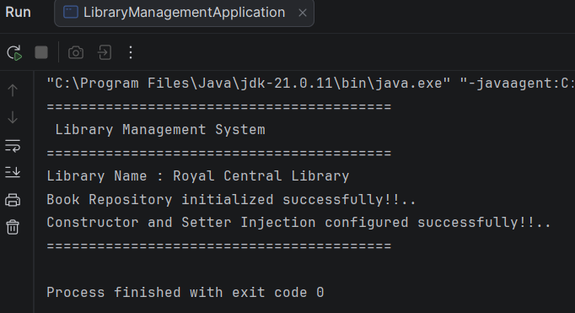

Screenshots
- Project Structure
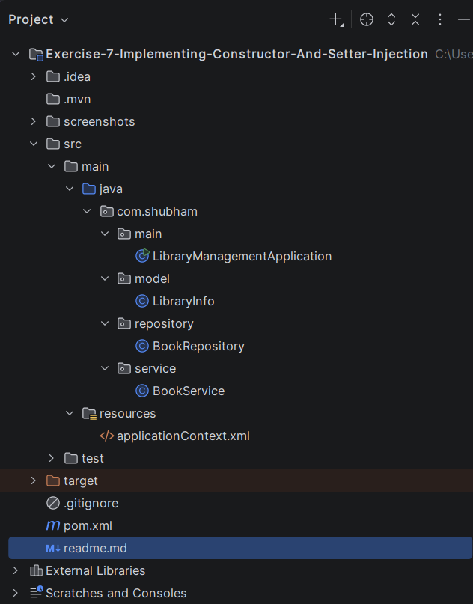
- pom.xml
<?xml version="1.0" encoding="UTF-8"?>
<project xmlns="http://maven.apache.org/POM/4.0.0"
xmlns:xsi="http://www.w3.org/2001/XMLSchema-instance"
xsi:schemaLocation="
http://maven.apache.org/POM/4.0.0
https://maven.apache.org/xsd/maven-4.0.0.xsd">
<modelVersion>4.0.0</modelVersion>
<groupId>com.shubham</groupId>
<artifactId>exercise-7-implementing-constructor-and-setter-injection</artifactId>
<version>1.0-SNAPSHOT</version>
<properties>
<maven.compiler.source>21</maven.compiler.source>
<maven.compiler.target>21</maven.compiler.target>
<spring.version>5.3.39</spring.version>
</properties>
<dependencies>
<dependency>
<groupId>org.springframework</groupId>
<artifactId>spring-context</artifactId>
<version>${spring.version}</version>
</dependency>
</dependencies>
</project>

- LibraryInfo.java
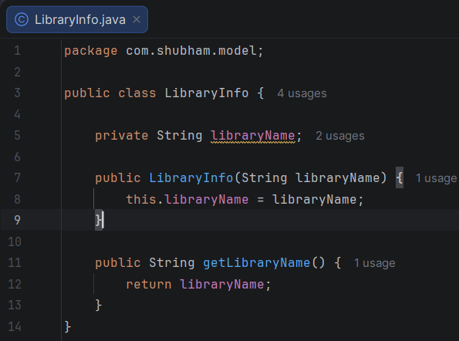
- BookRepository.java
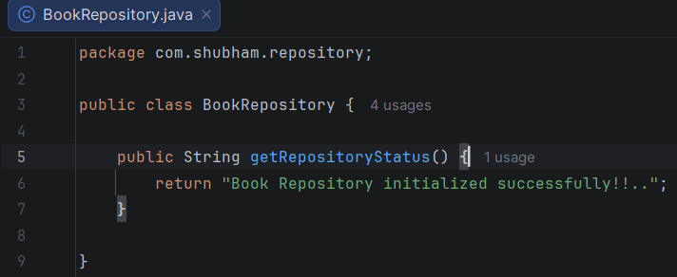

- BookService.java
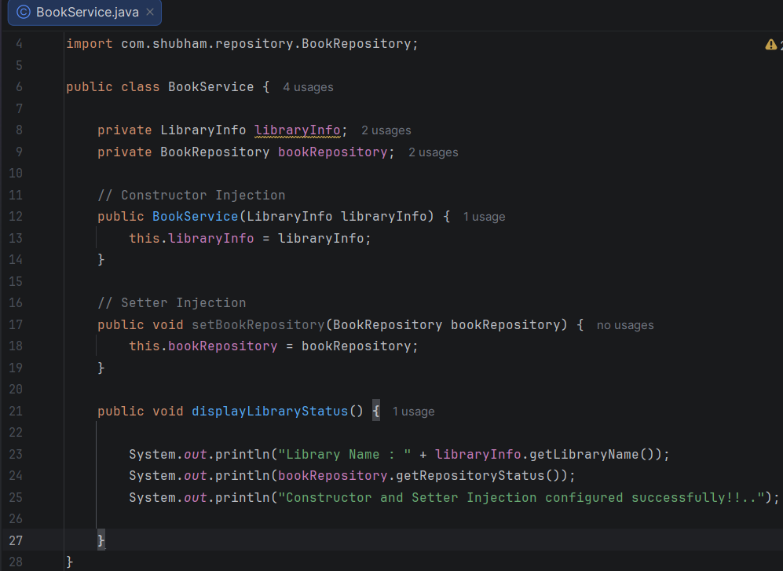

- applicationContext.xml
<?xml version="1.0" encoding="UTF-8"?>
<beans xmlns="http://www.springframework.org/schema/beans"
xmlns:xsi="http://www.w3.org/2001/XMLSchema-instance"
xsi:schemaLocation="
http://www.springframework.org/schema/beans
https://www.springframework.org/schema/beans/spring-beans.xsd">
<bean id="libraryInfo"
class="com.shubham.model.LibraryInfo">
<constructor-arg value="Royal Central Library"/>
</bean>
<bean id="bookRepository"
class="com.shubham.repository.BookRepository"/>
<bean id="bookService"
class="com.shubham.service.BookService">
<!-- Constructor Injection -->
<constructor-arg ref="libraryInfo"/>
<!-- Setter Injection -->
<property name="bookRepository"
ref="bookRepository"/>
</bean>
</beans>

- LibraryManagementApplication.java
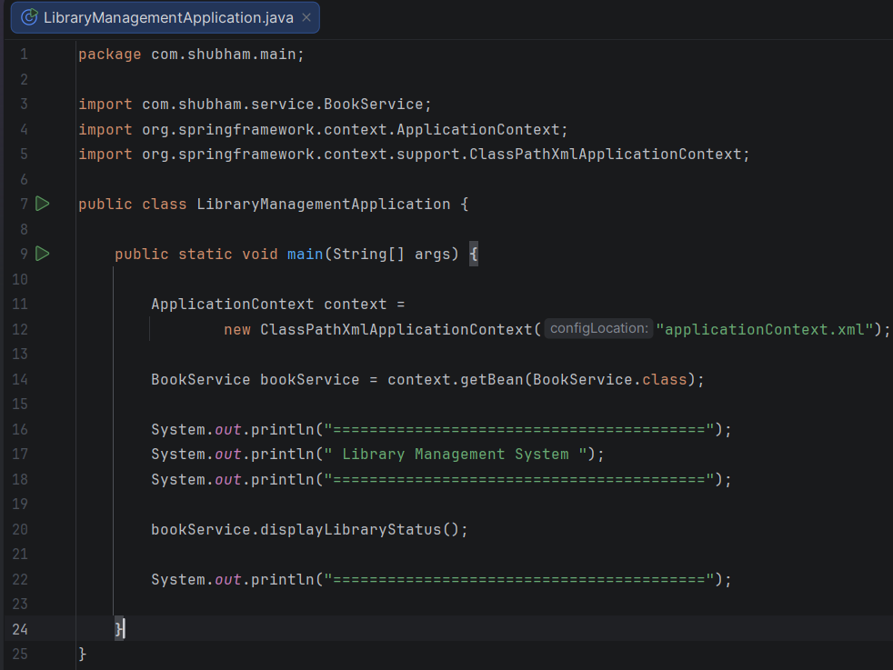

Result
The application successfully demonstrated both Constructor Injection and Setter Injection using the Spring IoC Container. The required dependencies were injected correctly, and the application executed successfully.

Conclusion
This exercise demonstrated the implementation of Constructor Injection and Setter Injection in Spring using XML configuration. Both techniques were successfully used to manage dependencies in the Library Management application, resulting in a clean and maintainable design.

